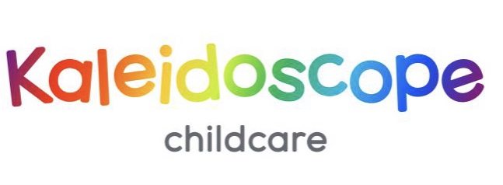
Code of Conduct Policy for Parents and Carers

At Kaleidoscope Childcare, the education and care of children is a partnership between staff, parents and carers. We are all aware of the importance of good working relationships and so we aim to provide a friendly, respectful and safe environment for all children, families, staff, volunteers and visitors. In turn we would like parents and carers to adhere to this code which provides the expectations of their conduct as listed below:
Please do:
- Share information with staff about your child’s development, health and well-being and any change in family circumstances
- Let us know if someone else will be collecting your child other than their immediate family
- Collect your child on time. If you are going to be unavoidably late, please contact us and try to arrange for someone else to collect your child.
- Discuss any concerns about your child’s development or well-being with your child’s key person, our SENCo, or the manager as appropriate.
- Discuss any concerns or complaints with your child’s key person or the manager as appropriate. See our Complaints Policy for more guidance.
Please refrain from:
- Discussing sensitive issues within in earshot of your child, other children or other adults
- Using your mobile phone whilst in the Kaleidoscope building as outlined in our Safeguarding Policy
Behaviour that will not be tolerated:
- Shouting at, smacking or physically punishing your child or any other child whilst on Kaleidoscope premises
- Approaching someone else’s child in order to discuss or chastise them because of the actions of this child towards their own child. (Such an approach to a child may be seen as an assault on that child and may have legal consequences)
- Using inappropriate, offensive language or displaying aggressive or intimidating behaviour towards staff, children or other parents/carers either in person, on the phone or in writing
- Threatening in any way a member of staff, parent/carer, visitor or child
- Sending abusive or threatening emails or text/voicemail/phone messages or other written communications (including social media) to anyone who attends Kaleidoscope.
- Defamatory, offensive or derogatory comments placed on Facebook or other social media sites regarding Kaleidoscope or any of the children, parents or staff who attend Kaleidoscope.
- Collecting your child from Kaleidoscope if you have consumed alcohol, medication or other substances that may affect your judgement or responses.
- Smoking, taking illegal drugs or consumption of alcohol on Kaleidoscope premises

Breach of this Code of Conduct
Any breach of this code of conduct will be taken very seriously and dealt with promptly as follows:
- Management will seek to have a meeting with the parent or carer to discuss the behaviour and try to find a resolution for any issues.
- Trustees will be informed of the situation and may discuss the issues and decide on an appropriate course of action
- A letter may be sent to the parent or carer addressing the behaviour and stating our expectations of future behaviour
- If the inappropriate behaviour continues the trustees may decide that we will have to cease offering our services to the family.
- In cases where unacceptable behaviour is considered to be a serious and potentially a criminal matter, the concerns will in the first instance be referred to the Police. This will include any or all cases of threats or violence and actual violence to any child, staff, parent or visitor in Kaleidoscope. This will also include anything that could be seen as a sign of harassment of any member of the Kaleidoscope community such as any form of insulting social media post or any form of social media cyber bullying. Other outside agencies may be informed and advice sought.

Date: 1/9/26
Reviewed: August 2027
Name: Kim Olsen
Signature: Kim Olsen
Position: Nursery Manager

Signed on behalf of the charity
Name: Ben Dawson
Signature: Ben Dawson
Position: Chair

